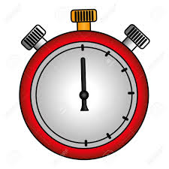
Multi vitesse 2
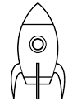
5 X 5 =
7 X 8 =
4 X 10 =
10 X 6 =
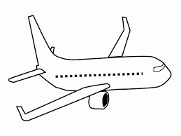
7 X 7 =
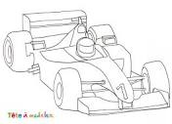
11 X 9 =
20 X 50 =
25 X 4 =
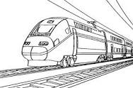
3 X 6 =
4 x 60 =
30 X 10 =
400 X 50 =
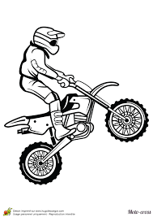
3 X 7 =
5 X 9 =
15 X 3 =
12 x 5 =
45 X 2 =
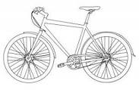
3 X 8 =
13 X 2 =
67 X 10 =
Temps : ………
Résultat : …/ 20

